A client-server network is a type of computer network in which:
➡️ Clients (computers, phones, or devices) request and use services or resources,
➡️ Servers provide those services or resources.

Definition:
A client-server network is a network architecture where multiple client devices connect to a central server to access data, applications, or services such as files, printers, or the internet.

Example:
- When you open a web browser (client) and access a website, your computer sends a request to the web server, which then sends the website data back to your browser.

Key Characteristics:
- Centralized control (server manages resources)
- Clients depend on the server
- Easier to manage and secure
- Common in businesses and organizations

Example Servers:
- File server
- Web server
- Database server
- Mail server

A workgroup network is a type of peer-to-peer (P2P) network where all computers are equal and can share files, printers, or other resources without a central server.

Definition:
A workgroup network is a local area network (LAN) in which each computer acts as both a client and a server, allowing users to share resources directly with one another without centralized management.

Key Characteristics:
- No dedicated server — all computers are peers.
- Each user controls their own computer and resources.
- Simple to set up and manage.
- Best for small networks (usually fewer than 10 computers).
- Common in home or small office networks.

Example:
If you have three computers at home that share files and a printer over Wi-Fi without using a central server — that’s a workgroup network.
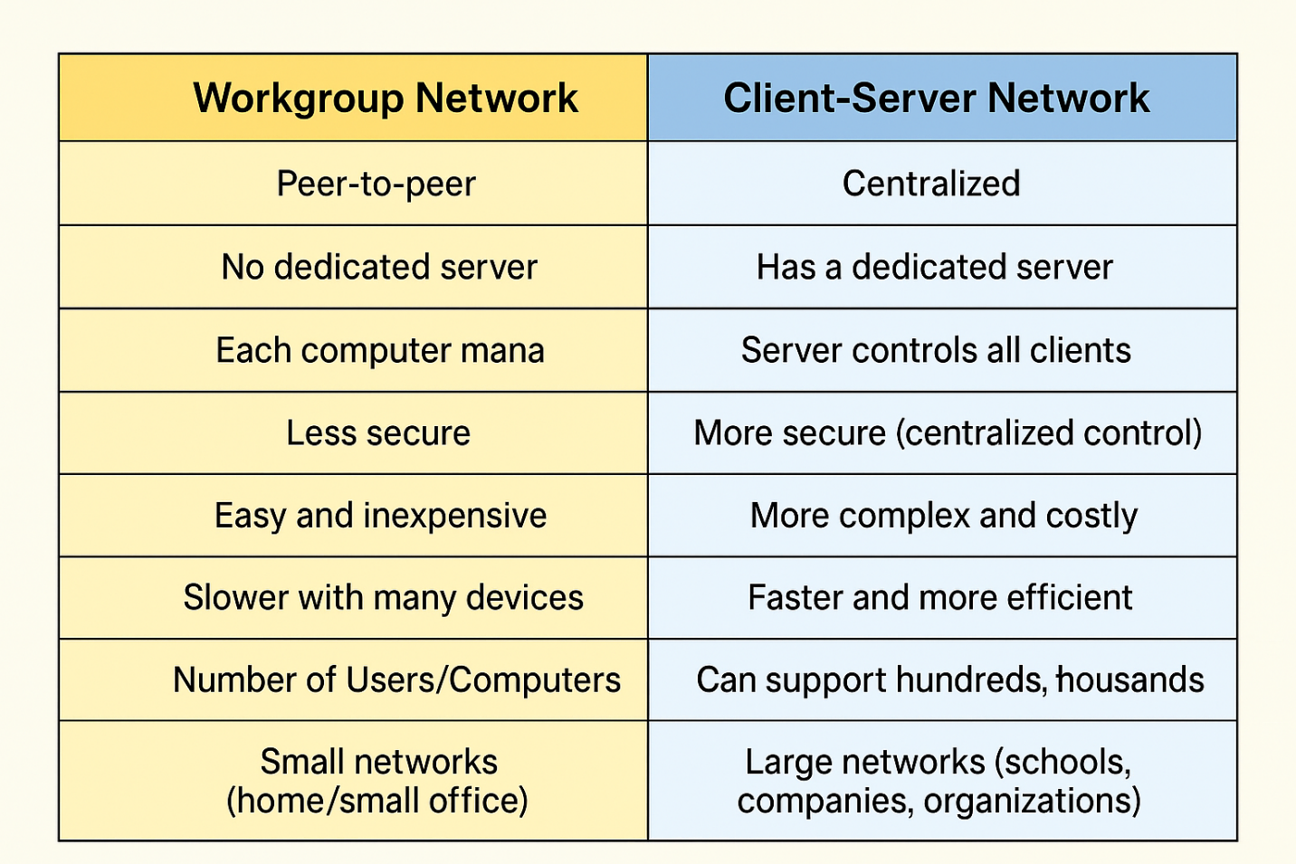

Virtualization is a technology that allows you to create multiple virtual versions of computer resources — such as operating systems, servers, storage, or networks — on a single physical machine.

Definition:
Virtualization is the process of creating a virtual (software-based) version of hardware or system resources, allowing one physical machine to run multiple independent environments.

Example:
Using VMware or VirtualBox to run Windows and Linux on the same computer at the same time.

Key Benefits:
- Better use of hardware resources
- Easier testing and development
- Lower cost
- Simplified management and backup

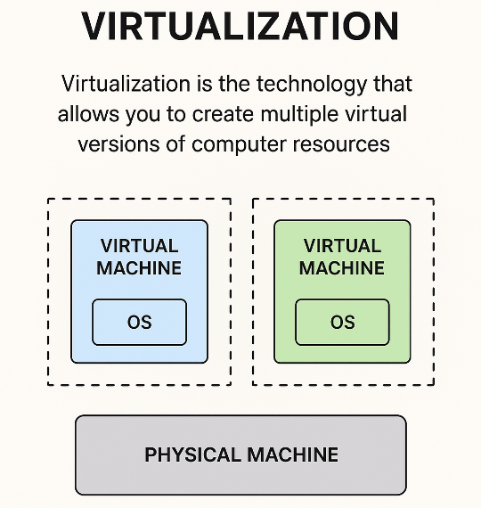

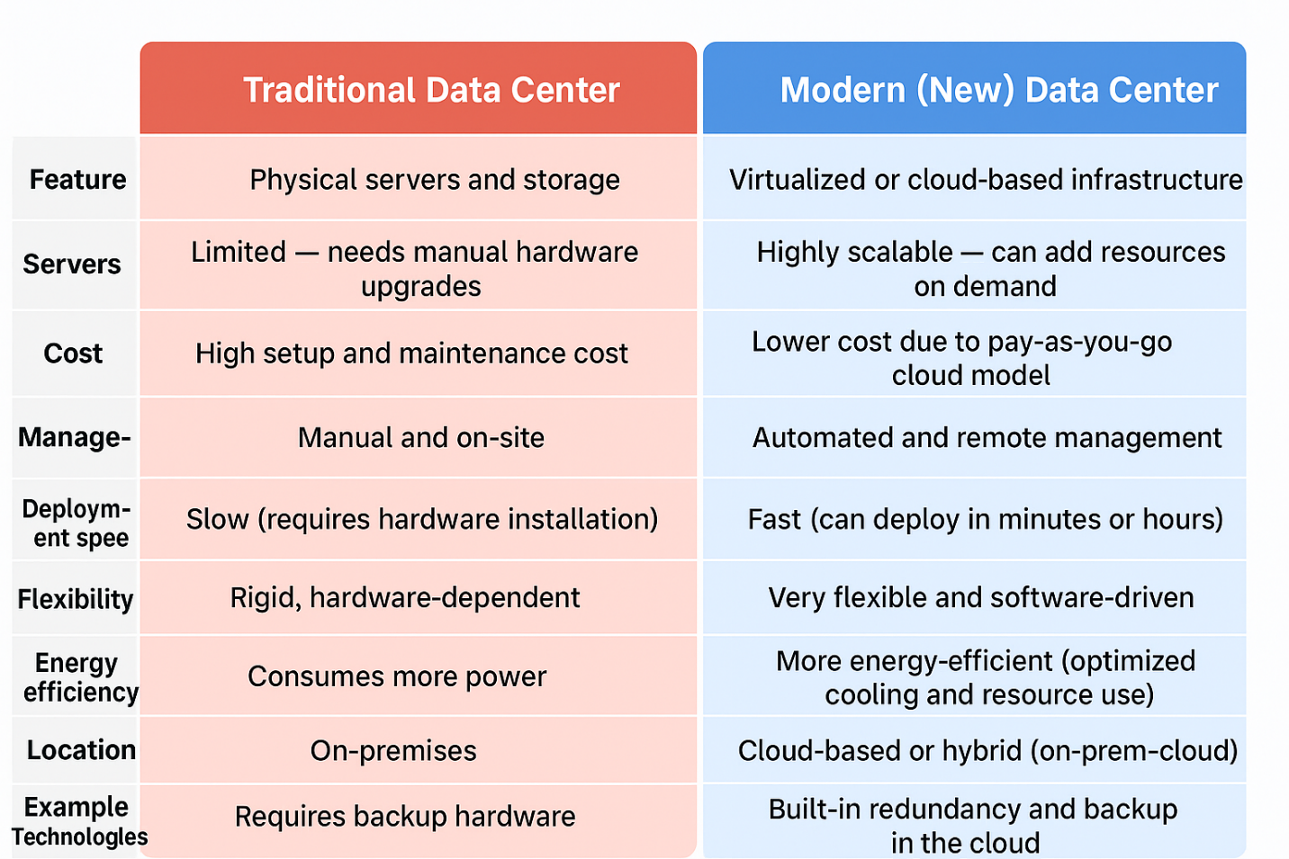

main specifications of servers

🖥️ 1. Processor (CPU)
- High-performance types such as Intel Xeon or AMD EPYC.
- Cores: Usually between 4 and 64 cores or more depending on the server type.

💾 2. Memory (RAM)
- Large capacity: from 16 GB up to 1 TB or more.
- Type: ECC RAM (Error-Correcting Code) – detects and fixes memory errors automatically.
- High-speed memory for better stability and performance.

🗄️ 3. Storage
- Types:
  - SSD → for high-speed performance (OS and applications).
  - HDD → for large data storage.
- Supports RAID technology for data protection and redundancy.

🌐 4. Network Interface Card (NIC)
- High-speed connectivity (1 Gbps, 10 Gbps, or higher).
- Often includes multiple ports for redundancy and load balancing

What is Server Manager?
Server Manager is the primary, integrated management console in Microsoft Windows Server. It provides administrators with a centralized graphical interface to manage, configure, and monitor both the local server and multiple remote servers across a network.
- Central Dashboard: Represents the unified interface for managing server operations.
- Local Server Management: Shows the direct configuration of the host server.
- Remote Server Management: Highlights the ability to manage multiple distant servers.
- Install/Remove Roles & Features: Emphasizes the main purpose of adding or removing server functionalities.
- Monitoring & Diagnostics: Points to the overview of server health, events, and performance.

The Server Manager Dashboard
The Dashboard is the main, starting screen of the Server Manager tool in Windows Server.

What is the Dashboard?
It is the central control panel that gives you an immediate, high-level overview of everything happening on your server (or all the servers you manage).

The Dashboard screen is divided into clear sections:
- Welcome Section:
  - This is where you see the basic tasks, like "Add Roles and Features" or "Add Other Servers to Manage." It’s your quick-start menu.
- Local Server Pane:
  - This box gives you the core identity of the computer you are physically using. It confirms the Computer Name, the IP Address, and if the Firewall is on.
- Roles and Server Groups Pane:
  - This is the most critical area. It lists every major job (Role) your server is supposed to do.
  - The Status Signal:
    - 🟢 Green: Everything is Healthy and running perfectly.
    - 🟡 Yellow/Warning: Something needs attention (e.g., low disk space, a non-critical event).
    - 🔴 Red/Critical: A major service or role has failed and requires immediate fixing.
- Events, Services, and Performance Tiles:
  - These tiles pull data directly from the system logs and performance monitors. You can see how many Errors have occurred recently and which System Services are currently running or stopped.

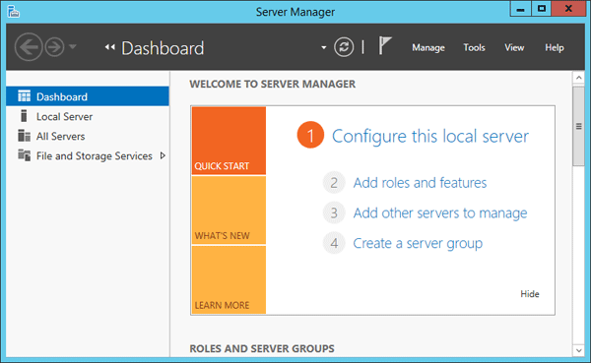

Type of server service
- Web Server
- Database Server
- File Server
- Mail Server
- Application Server
- DNS Server
- DHCP Server
- Proxy Server
- Print Server
- Domain Controller

A Role is a set of services and software that enables the server to perform a specific, primary function for the user community or the network.
When you install a Role, you are essentially dedicating the server to a major task, often requiring specialized configuration after installation:
- Example: Active Directory Domain Services (AD DS)
  - The Job: To manage all network identities (users) and security centrally.
  - The Result: The server becomes a Domain Controller, which is its new, specialized function in the network.

A Feature is a supporting software component that is generally not a primary network service offered directly to end-clients. Features are installed to augment the operating system or to provide necessary administrative tools
Component | Role (الدور) | Feature (الميزة)
Primary Purpose | Defines the primary purpose of the server. It makes the server a specialized type of machine. | Enhances functionality for the server itself or for an installed Role.
Functionality | Major services provided to clients across the network. | Supplementary tools, protocols, or management snap-ins.
Impact | Generally requires more configuration (often including a Promotion step) and significantly changes the server's identity. | Typically requires less configuration and provides supporting services.
Examples | DHCP Server, DNS Server, Web Server (IIS), Active Directory Domain Services (AD DS), Hyper-V. | Group Policy Management, Failover Clustering, Telnet Client, Data Deduplication.

